Tingrith
We want to hear your views on the sites that have been submitted, including any local concerns about particular sites and the reasons for them. We will need to allocate sites in the Local Plan, so we are also keen to understand, if you had to pick some, which sites you would prefer to be allocated in the parish. Please mention this in your comments.
The proposed use sets out what type of development the site is being promoted for. Where 'other' is listed alongside a specified use, this can refer to facilities such as schools, community buildings and other supporting infrastructure.
Site 135312
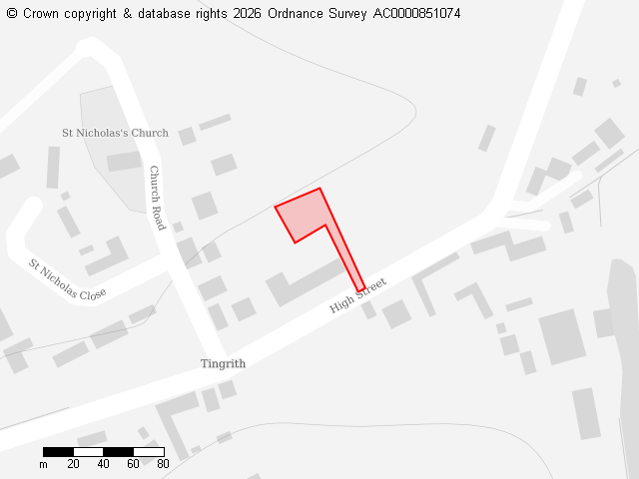
Ward
Westoning, Flitton & Greenfield
Parish
Tingrith
Total Site Size (hectares)
0.11
Proposed Use
Residential

Site 136372
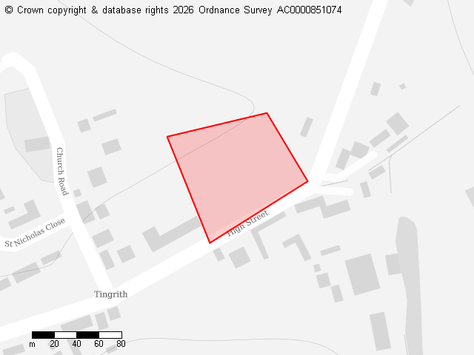
Ward
Westoning, Flitton & Greenfield
Parish
Tingrith
Total Site Size (hectares)
0.83
Proposed Use
Residential

