Stotfold
We want to hear your views on the sites that have been submitted, including any local concerns about particular sites and the reasons for them. We will need to allocate sites in the Local Plan, so we are also keen to understand, if you had to pick some, which sites you would prefer to be allocated in the parish. Please mention this in your comments.
The proposed use sets out what type of development the site is being promoted for. Where 'other' is listed alongside a specified use, this can refer to facilities such as schools, community buildings and other supporting infrastructure.
Site 135288
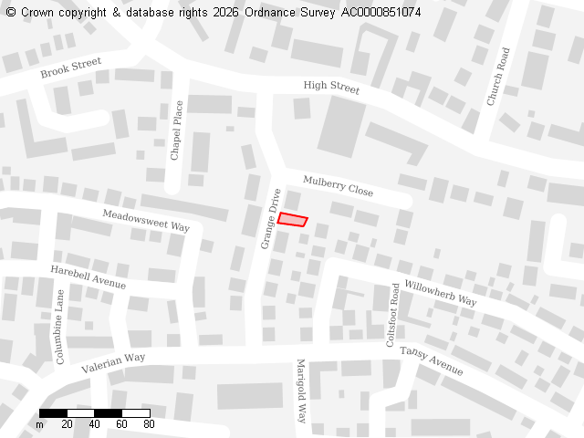
Ward
Stotfold
Parish
Stotfold
Total Site Size (hectares)
0.01
Proposed Use
Residential, Standalone green spaces

Site 135289
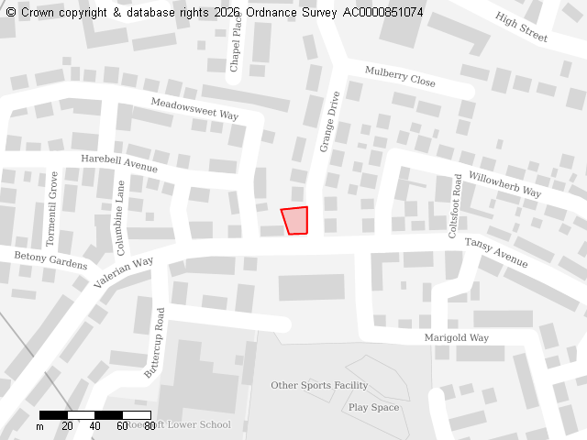
Ward
Stotfold
Parish
Stotfold
Total Site Size (hectares)
0.03
Proposed Use
Residential, Standalone green spaces

Site 135290
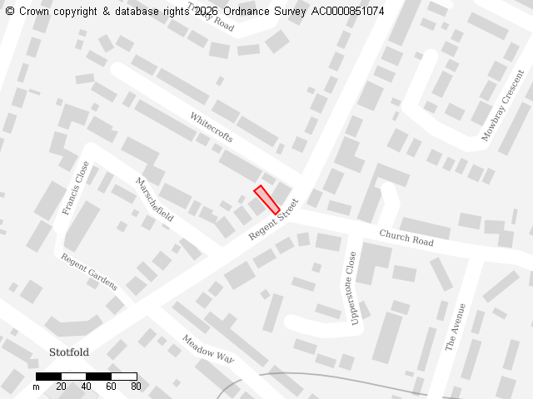
Ward
Stotfold
Parish
Stotfold
Total Site Size (hectares)
0.01
Proposed Use
Residential

Site 135291
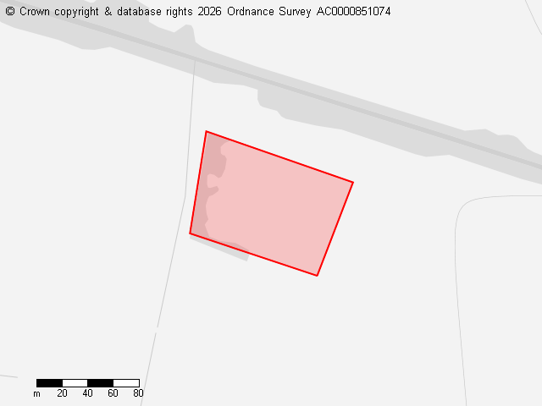
Ward
Stotfold
Parish
Stotfold
Total Site Size (hectares)
0.89
Proposed Use
Residential, Gypsy and Traveller pitches, Standalone green spaces, Other

Site 136330
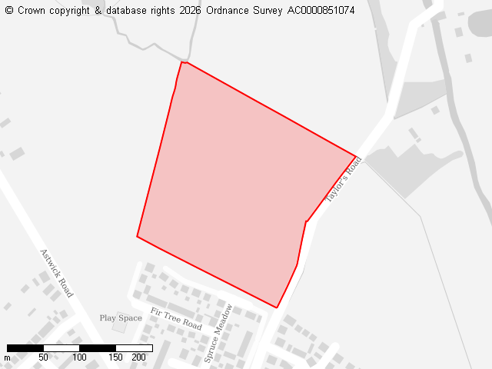
Ward
Stotfold
Parish
Stotfold
Total Site Size (hectares)
5.65
Proposed Use
Residential

Site 136331
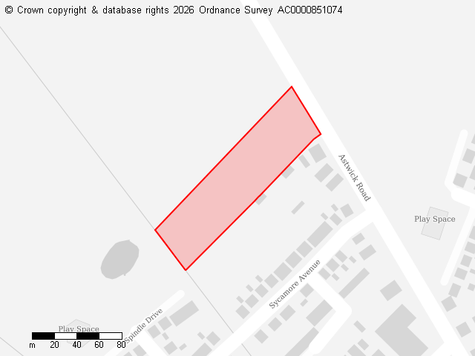
Ward
Stotfold
Parish
Stotfold
Total Site Size (hectares)
0.8
Proposed Use
Residential

Site 136332
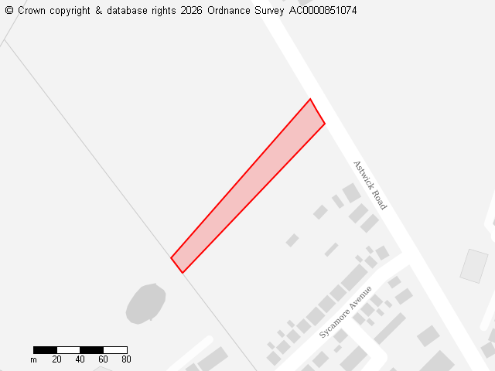
Ward
Stotfold
Parish
Stotfold
Total Site Size (hectares)
0.35
Proposed Use
Residential

Site 136394
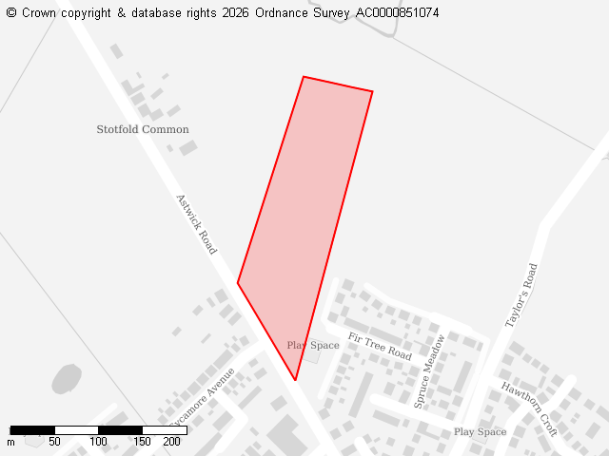
Ward
Stotfold
Parish
Stotfold
Total Site Size (hectares)
2.56
Proposed Use
Residential

Site 136475
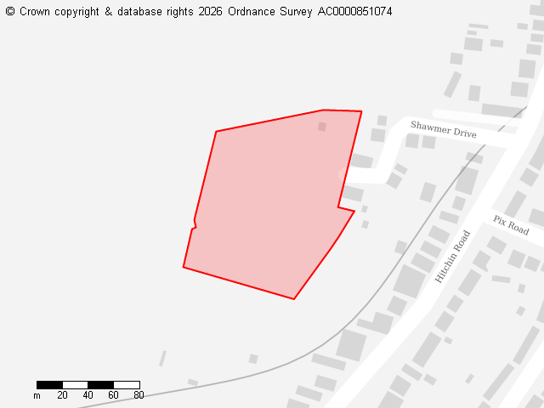
Ward
Stotfold
Parish
Stotfold
Total Site Size (hectares)
1.42
Proposed Use
Residential

Site 136484
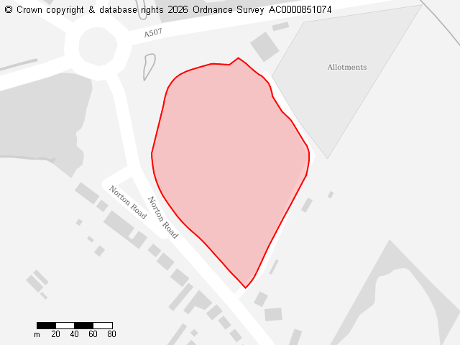
Ward
Stotfold
Parish
Stotfold
Total Site Size (hectares)
2.47
Proposed Use
Residential, Employment

Site 136563
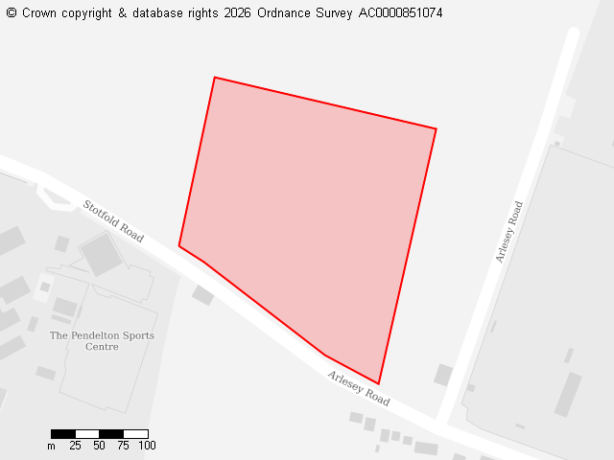
Ward
Stotfold
Parish
Stotfold
Total Site Size (hectares)
5.04
Proposed Use
Residential

Site 136673
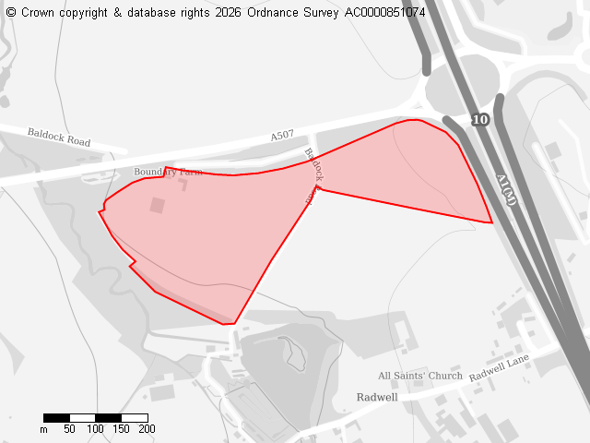
Ward
Stotfold
Parish
Stotfold
Total Site Size (hectares)
12.09
Proposed Use
Employment

Site 136736
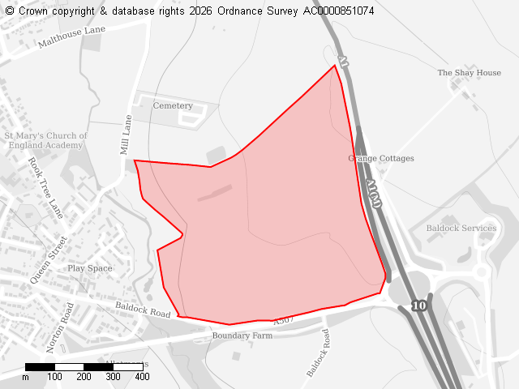
Ward
Stotfold
Parish
Stotfold
Total Site Size (hectares)
44.04
Proposed Use
Employment

Site 136745
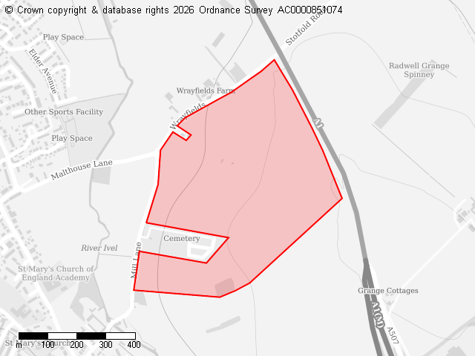
Ward
Stotfold
Parish
Stotfold
Total Site Size (hectares)
32.89
Proposed Use
Residential

Site 136760
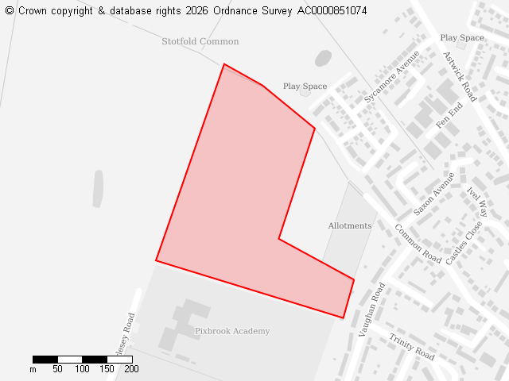
Ward
Stotfold
Parish
Stotfold
Total Site Size (hectares)
10.21
Proposed Use
Residential

Site 136761
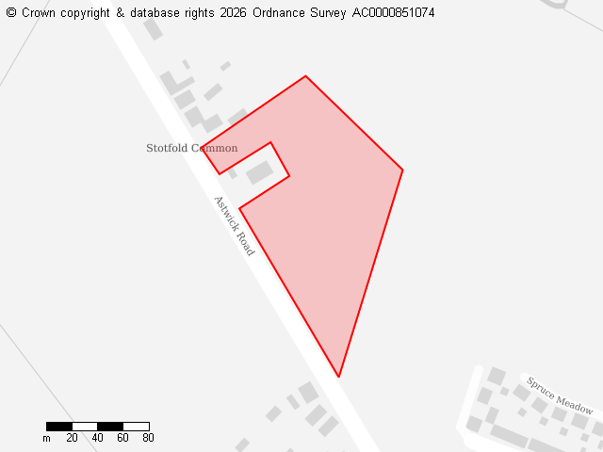
Ward
Stotfold
Parish
Stotfold
Total Site Size (hectares)
1.61
Proposed Use
Residential

Site 136800
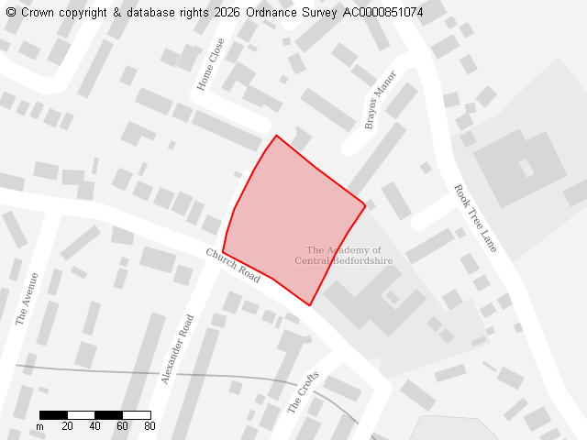
Ward
Stotfold
Parish
Stotfold
Total Site Size (hectares)
0.69
Proposed Use
Residential

