Henlow
We want to hear your views on the sites that have been submitted, including any local concerns about particular sites and the reasons for them. We will need to allocate sites in the Local Plan, so we are also keen to understand, if you had to pick some, which sites you would prefer to be allocated in the parish. Please mention this in your comments.
The proposed use sets out what type of development the site is being promoted for. Where 'other' is listed alongside a specified use, this can refer to facilities such as schools, community buildings and other supporting infrastructure.
Site 135347
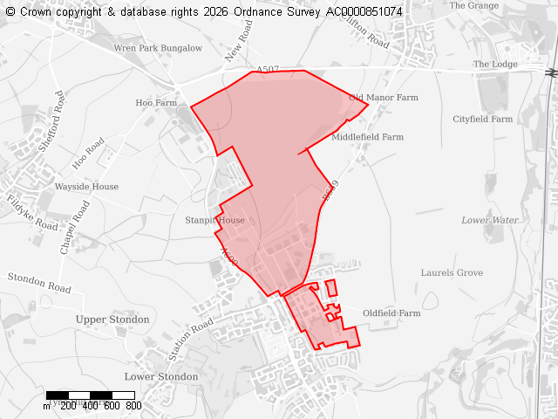
Ward
Clifton, Henlow & Langford
Parish
Henlow
Total Site Size (hectares)
199.36
Proposed Use
Residential, Employment, Green energy, Standalone green spaces, Other

Site 135351
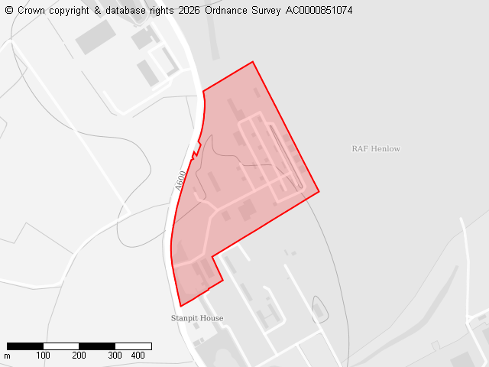
Ward
Clifton, Henlow & Langford
Parish
Henlow
Total Site Size (hectares)
13.86
Proposed Use
Employment

Site 136336
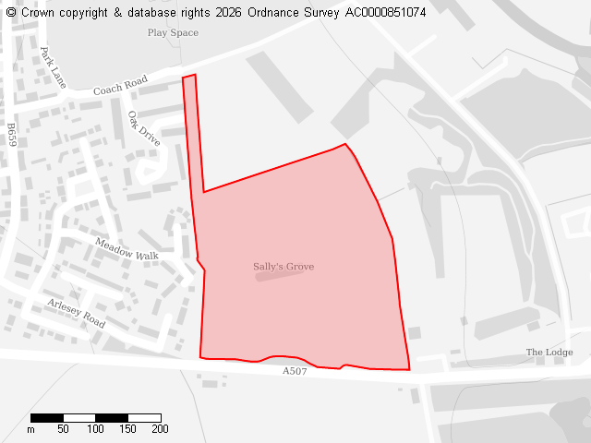
Ward
Clifton, Henlow & Langford
Parish
Henlow
Total Site Size (hectares)
9.21
Proposed Use
Residential, Employment, Gypsy and Traveller pitches, Other

Site 136364
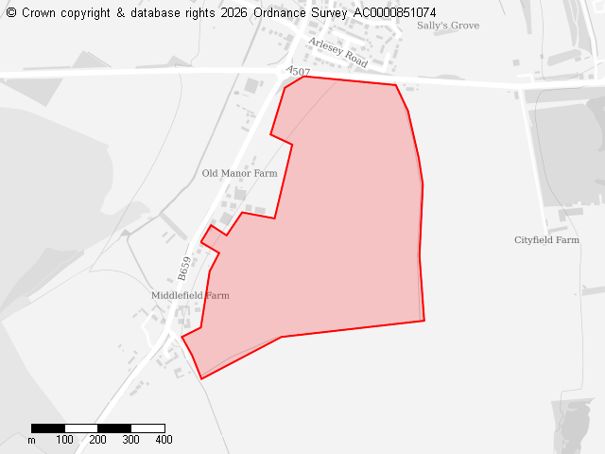
Ward
Clifton, Henlow & Langford
Parish
Henlow
Total Site Size (hectares)
38.85
Proposed Use
Residential, Employment, Standalone green spaces, Other

Site 136371
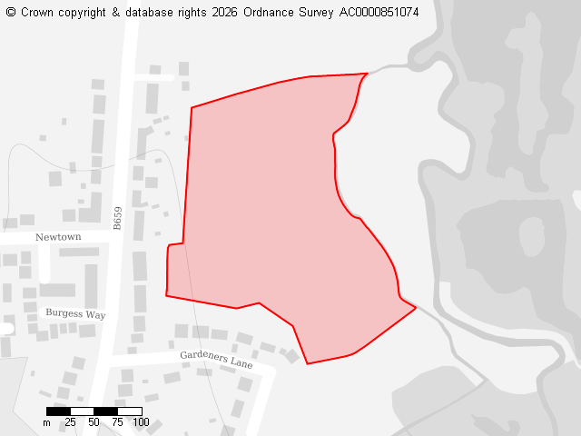
Ward
Clifton, Henlow & Langford
Parish
Henlow
Total Site Size (hectares)
4.8
Proposed Use
Residential, Standalone green spaces

Site 136382
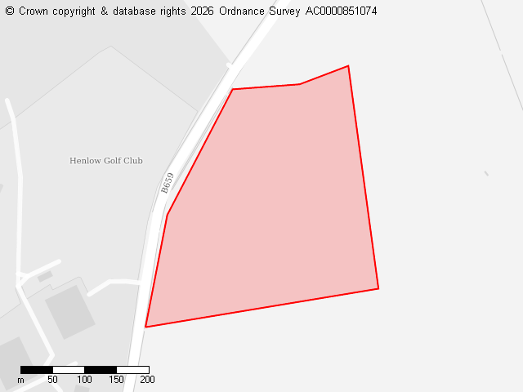
Ward
Clifton, Henlow & Langford
Parish
Henlow
Total Site Size (hectares)
9.81
Proposed Use
Residential, Other

Site 136391
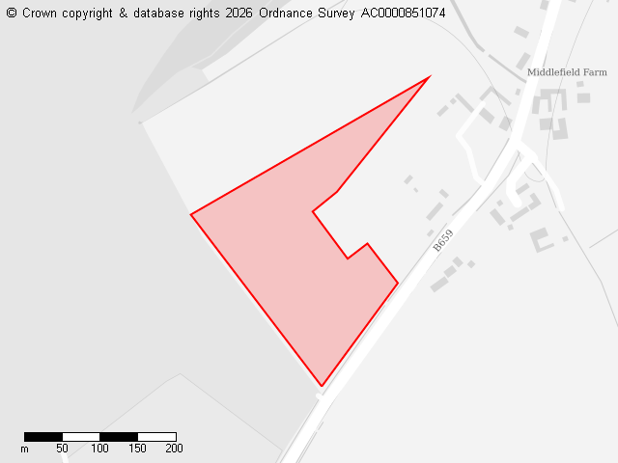
Ward
Clifton, Henlow & Langford
Parish
Henlow
Total Site Size (hectares)
4.51
Proposed Use
Residential

Site 136434
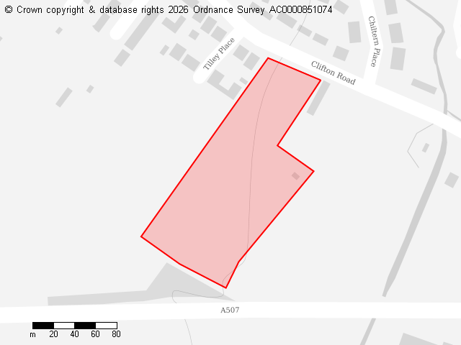
Ward
Clifton, Henlow & Langford
Parish
Henlow
Total Site Size (hectares)
1.67
Proposed Use
Residential

Site 136452
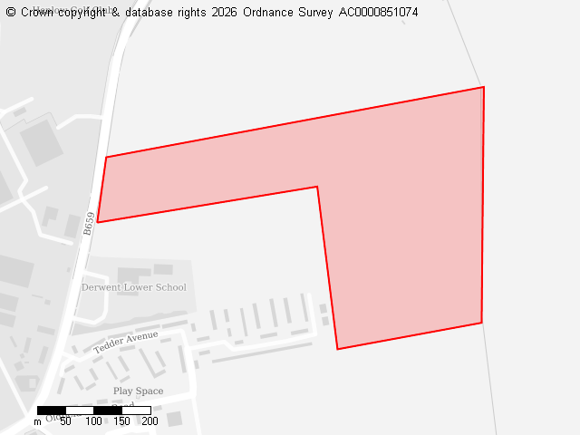
Ward
Clifton, Henlow & Langford
Parish
Henlow
Total Site Size (hectares)
16.25
Proposed Use
Residential

Site 136453
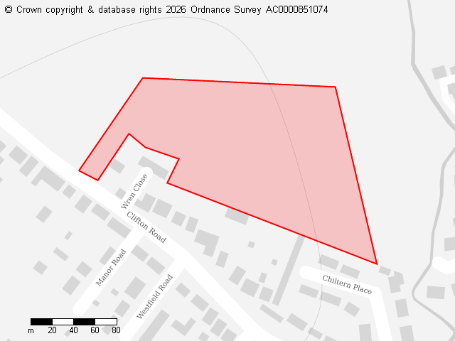
Ward
Clifton, Henlow & Langford
Parish
Henlow
Total Site Size (hectares)
2.55
Proposed Use
Residential

Site 136587
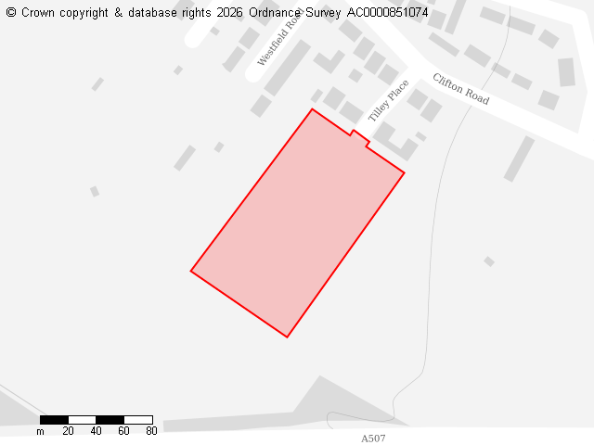
Ward
Clifton, Henlow & Langford
Parish
Henlow
Total Site Size (hectares)
1.18
Proposed Use
Residential

Site 136590
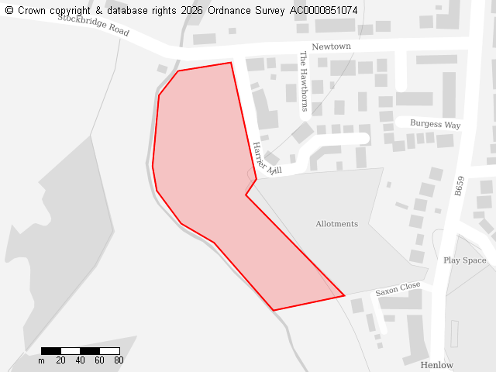
Ward
Clifton, Henlow & Langford
Parish
Henlow
Total Site Size (hectares)
2.07
Proposed Use
Residential

Site 136763
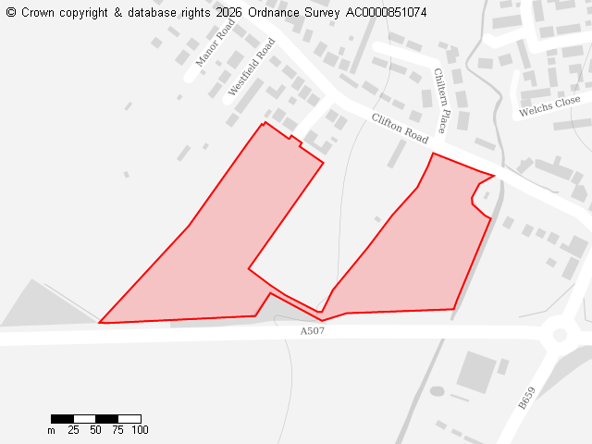
Ward
Clifton, Henlow & Langford
Parish
Henlow
Total Site Size (hectares)
4.23
Proposed Use
Residential

Site 136913
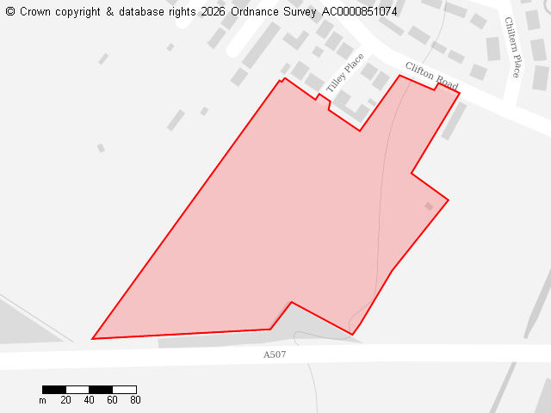
Ward
Clifton, Henlow & Langford
Site Name
136913
Parish
Henlow
Total Site
3.95
What the land has been submitted for
Residential

