Cranfield
We want to hear your views on the sites that have been submitted, including any local concerns about particular sites and the reasons for them. We will need to allocate sites in the Local Plan, so we are also keen to understand, if you had to pick some, which sites you would prefer to be allocated in the parish. Please mention this in your comments.
The proposed use sets out what type of development the site is being promoted for. Where 'other' is listed alongside a specified use, this can refer to facilities such as schools, community buildings and other supporting infrastructure.
Site 136259
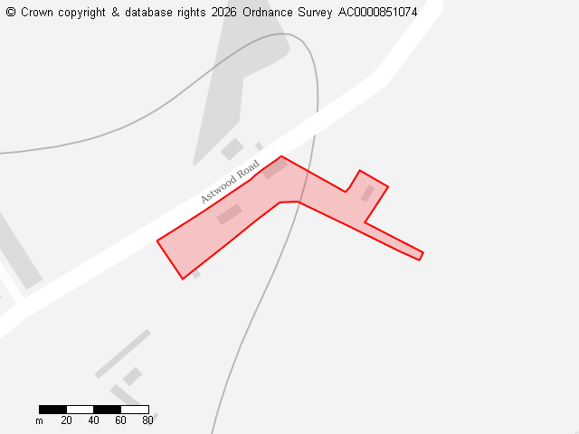
Ward
Cranfield & Marston Moretaine
Parish
Cranfield
Total Site Size (hectares)
0.53
Proposed Use
Residential, Other

Site 136270
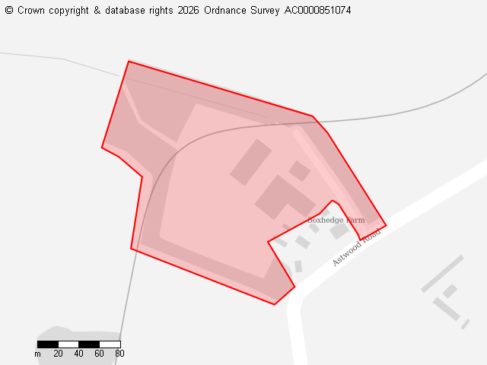
Ward
Cranfield & Marston Moretaine
Parish
Cranfield
Total Site Size (hectares)
3.42
Proposed Use
Residential, Employment

Site 136456
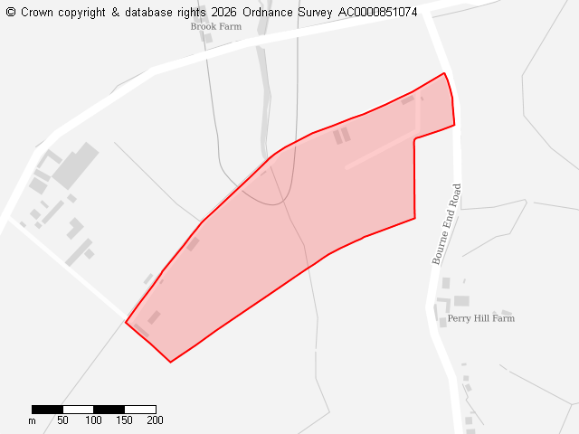
Ward
Cranfield & Marston Moretaine
Parish
Cranfield
Total Site Size (hectares)
8.91
Proposed Use
Employment

Site 136474
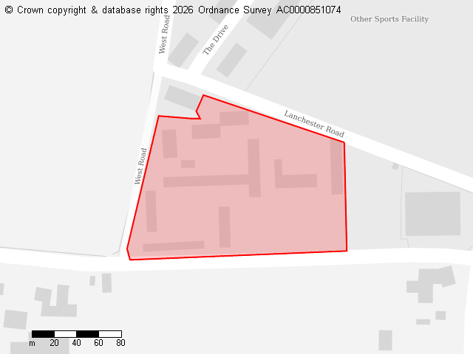
Ward
Cranfield & Marston Moretaine
Parish
Cranfield
Total Site Size (hectares)
2.24
Proposed Use
Residential

Site 136478
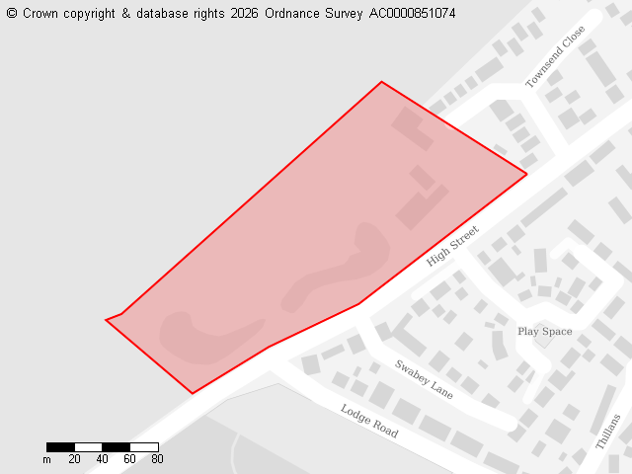
Ward
Cranfield & Marston Moretaine
Parish
Cranfield
Total Site Size (hectares)
2.79
Proposed Use
Residential

Site 136521
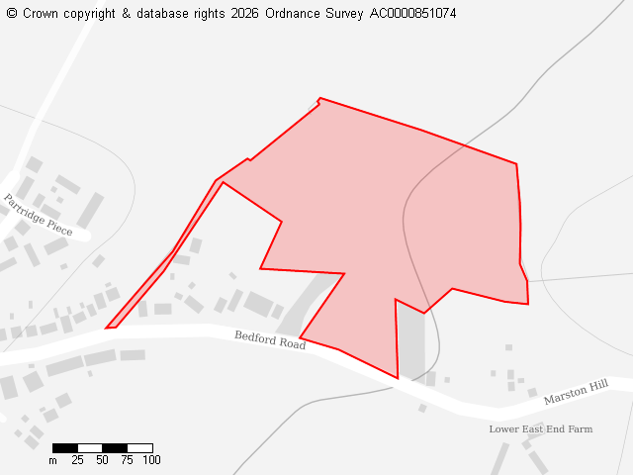
Ward
Cranfield & Marston Moretaine
Parish
Cranfield
Total Site Size (hectares)
4.74
Proposed Use
Residential

Site 136604
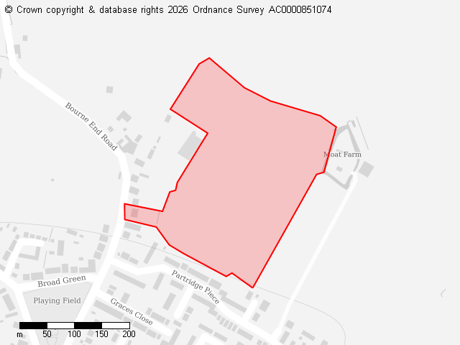
Ward
Cranfield & Marston Moretaine
Parish
Cranfield
Total Site Size (hectares)
7.62
Proposed Use
Residential

Site 136635
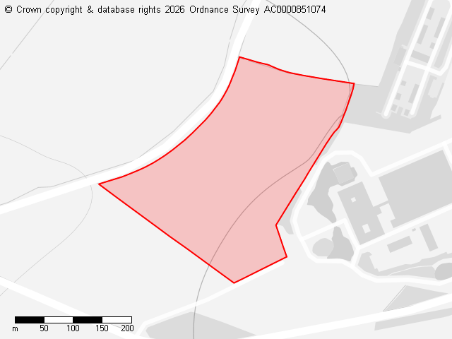
Ward
Cranfield & Marston Moretaine
Parish
Cranfield
Total Site Size (hectares)
8.13
Proposed Use
Employment

Site 136688
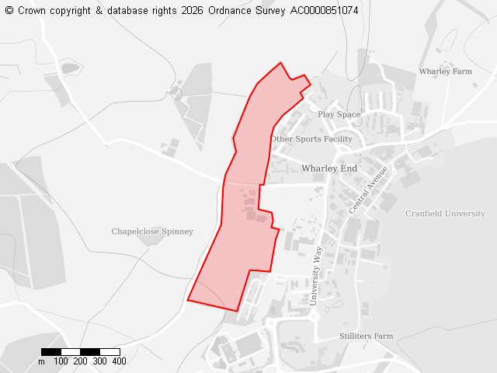
Ward
Cranfield & Marston Moretaine
Parish
Cranfield
Total Site Size (hectares)
28.26
Proposed Use
Residential, Other

Site 136712
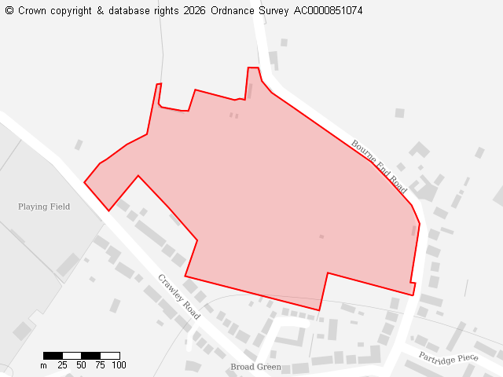
Ward
Cranfield & Marston Moretaine
Parish
Cranfield
Total Site Size (hectares)
7.51
Proposed Use
Residential

Site 136733
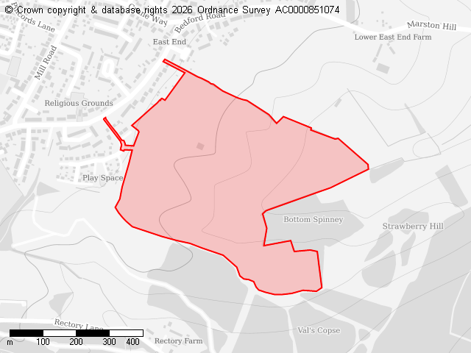
Ward
Cranfield & Marston Moretaine
Parish
Cranfield
Total Site Size (hectares)
27.04
Proposed Use
Residential

Site 136738
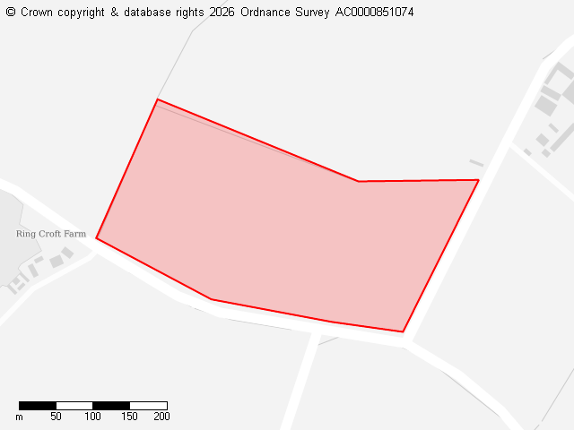
Ward
Cranfield & Marston Moretaine
Parish
Cranfield
Total Site Size (hectares)
8.97
Proposed Use
Residential, Employment

Site 136740
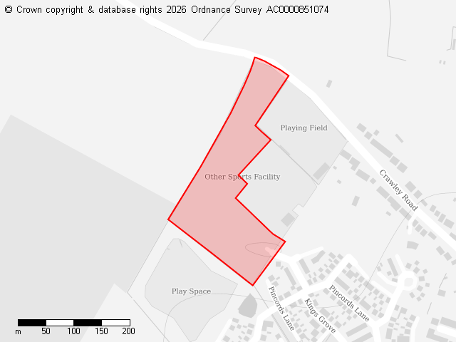
Ward
Cranfield & Marston Moretaine
Parish
Cranfield
Total Site Size (hectares)
3.59
Proposed Use
Employment

Site 136757
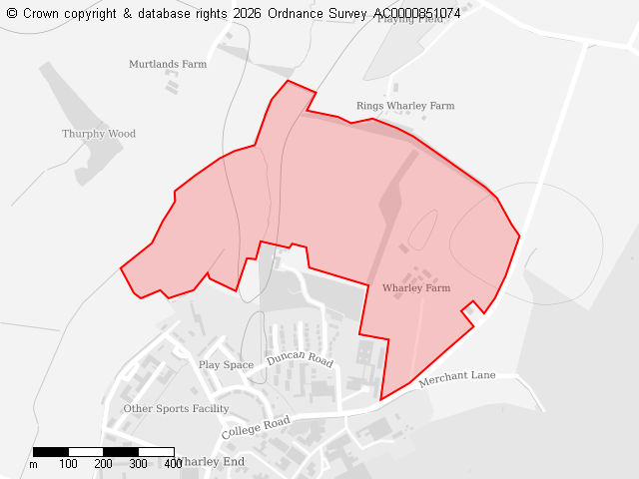
Ward
Cranfield & Marston Moretaine
Parish
Cranfield
Total Site Size (hectares)
45.36
Proposed Use
Residential, Employment, Other

Site 136820
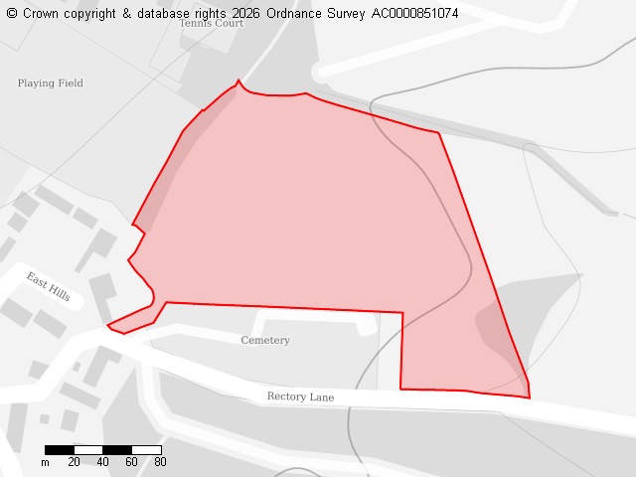
Ward
Cranfield & Marston Moretaine
Parish
Cranfield
Total Site Size (hectares)
3.48
Proposed Use
Residential, Other

Site 136897
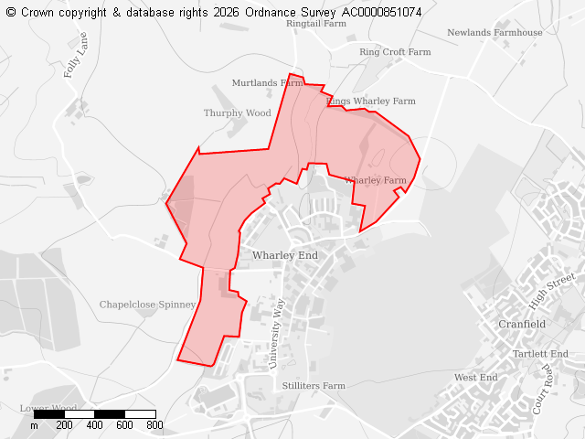
Ward
Cranfield & Marston Moretaine
Site Name
136897
Parish
Cranfield
Total Site
103.39
What the land has been submitted for
Residential, Employment

